**News Release**

Jurupa Community Services District Inaugurates First

Heli-Hydrant in the Inland Empire

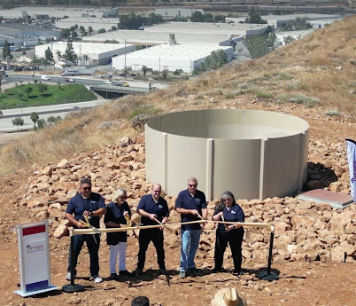***Jurupa Valley, CA* (September 5, 2024)** **–**The Jurupa Community Services District (JCSD) is proud to announce the inauguration of its first Heli-Hydrant, the first of its kind in the Inland Empire, marking a significant advancement in regional emergency response capabilities. This groundbreaking project enhances JCSD's commitment to community safety and firefighting efficiency. A Notice of Completion was presented to the JCSD Board of Directors yesterday evening, signifying the project's successful implementation.

The newly installed Heli-Hydrant, located in Jurupa Valley’s Country Village neighborhood, is designed to support firefighting helicopters by providing a rapid water source for aerial firefighting efforts. This 15-foot-wide, nearly 10,000-gallon tank can be quickly filled and activated by approaching helicopters, drastically reducing the time required to combat fires.

“The JCSD Heli-Hydrant is a critical tool to our region’s emergency response strategy,” said JCSD Board President Bart Moreno. “This project reflects JCSD’s proactive approach to public safety and our dedication to employing innovative solutions to protect our community – setting a precedent for emergency preparedness in the region and ensuring that our firefighters have the resources they need to respond to fires more effectively and efficiently."

The Heli-Hydrant Project represents a significant leap forward in JCSD's ability to meet the unique challenges posed by regional threats, such as fire. Positioned strategically throughout the JCSD’s service area, these Heli-Hydrants ensure that firefighting teams have swift access to large volumes of water, enabling quicker response times during critical fire emergencies. The strategic placement of these hydrants significantly enhances the operational efficiency of emergency services, safeguarding both natural landscapes and residential communities against the spread of wildfires.

Moreover, the Heli-Hydrant initiative aligns with JCSD’s broader commitment to sustainability and resilience. By improving the infrastructure for emergency services, JCSD not only protects the community but also contributes to a model of preparedness that can be replicated in similar regions facing increased fire risk.

The completed Heli-Hydrant is the first of four planned across JCSD’s service areas in Eastvale and Jurupa Valley. All four will provide comprehensive coverage and enhance firefighting capabilities throughout the region.

To view a video about the project, please [click here](https://youtu.be/7jEfu4AX-ag?si=MfMgH4-1q0Hs4LoD).

*Founded in 1956, the Jurupa Community Services District is a public agency providing services and programs to Jurupa Valley and Eastvale. It is governed by a Board of Directors comprised of five elected representatives from both cities. Serving over 140,000 people in a 40-square-mile area, JCSD provides a variety of community services and programs, including water, sewer, streetlights, frontage landscape maintenance, graffiti abatement, and parks and recreation services.*

Arman Tarzi, Manager of Government & Public Affairs

# # #

](https://www.youtube.com/user/jcsdvideos)